Chapter 10, Problem 73.

If the input impedance is defined as Z_{in} = V_{s}/I_{s}, find the input impedance of the op amp circuit in Fig. 10.116 when R₁ = 10 kΩ, R₂ = 20 kΩ, C₁ = 10 nF,
C₂ = 20 nF, and ω = 5000 rad/s.

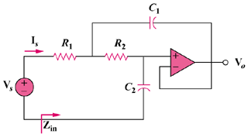

Figure 10.116
For Prob. 10.73.

